

Name: **RAVITRA RAJAH**

Login ID: ravitra@oasis-portal.com

Course title:[**ACCOUNTING FUNDAMENTALS**](http://study.oasis-portal.my/files/27/Accounting%20Fundamentals.pptx)

Subject Code: **BHM03**

Submitted date:14/08/2017

**Table of Contents**

|  |  |  |
| --- | --- | --- |
| No | Details | Page |
| 1 | Executive Summary | 3 |
| 2 | Introduction | 4-5 |
| 3 | Assignment Question |  |
|  | Part 1 | 6-9 |
|  | Part 2 | 10-13 |
|  | Part 3 | 14-16 |
|  | Part 4 | 17-20 |
| 4 | Conclusion | 21 |
| 5 | References | 22 |
| 6 | Appendix | 23 - 24 |

**Executive Summary**

In this assignment , I covered the topic about Accounting fundamentals. I’ve start of with Introduction of Accounting. What is the Accounting Fundamentals. Firstly, I elaborate about accounting concept meaning, double entry and role of accounting. Secondly, I have explain precisely the difference between accounts payable and accounts receivable. Thirdly, I have explain why does a company profit appear as a credit on its balance sheet. As a final touch, I will explain topic what is meant by reconciling an account.

INTRODUCTION ACCOUNTING

This explanation of accounting basics will introduce you to some basic accounting principles, accounting concepts, and accounting terminology. Some of the basic accounting terms that you will learn include revenues, expenses, assets, liabilities, income statement, balance sheet, and statement of cash flows. You will become familiar with accounting debits and credits as we show you how to record transactions. You will also see why two basic accounting principles, the revenue recognition principle and the matching principle, assure that a company's income statement reports a company's profitability. Accounting is system which records of financial transactions and reports of such transactions and for decision making purpose. As such it can be seen that the main role of accounting is to assist for better decision making. in terms of nature, size, location and form. It also a profession base and one part of accounting.

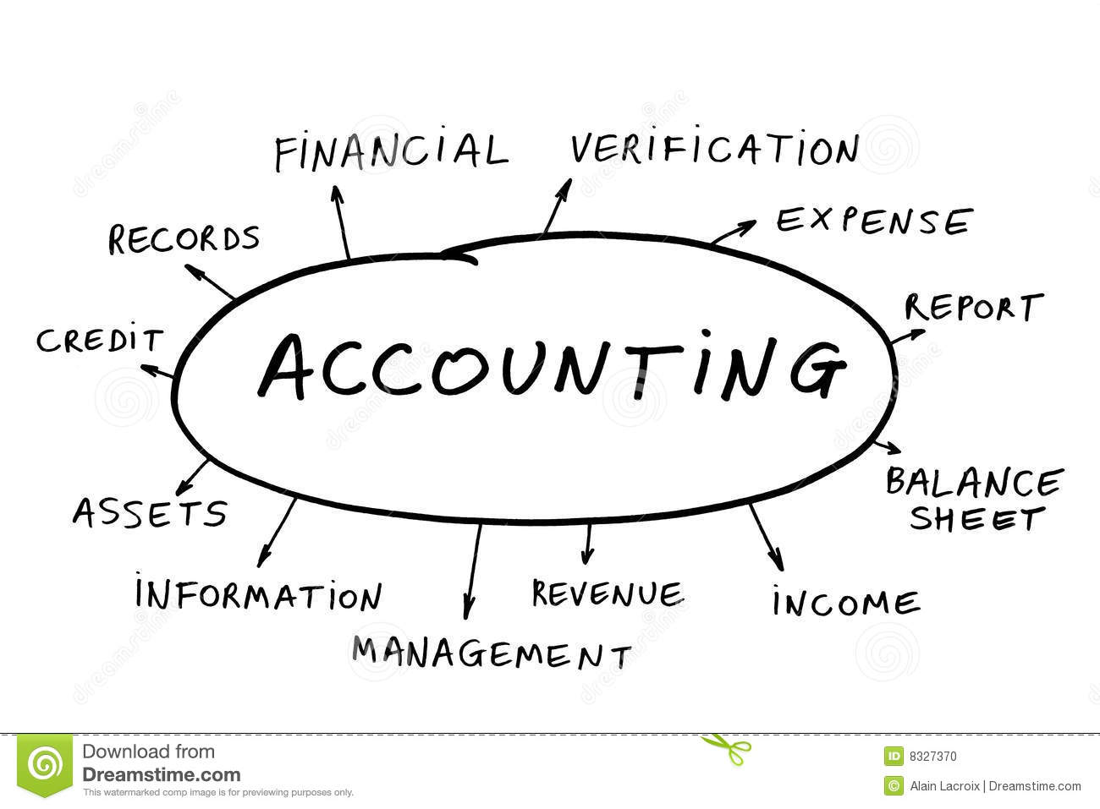

**Assignment Questions**

**Question 1**

In a brief but comprehensive response,define the role of accounting.

## The Role of Accounting

Accounting is the recording of financial transactions plus relrieving,summarizing and presenting the information in various reports and analyses.Accounting is also a profesion consisting of individual having the formal education to carry out these tasks. One part of accounting focuses on presenting the information in the form of general-purpose financial statements (balance sheet,income statement,etc.) to people outside of the company. This part of accounting is referred to as financial accounting. Accounting also entails providing a company’s management with the information it needs to keep the business financially healthy.These analyses and reports are not distributed outside of the company.Some of the information will originate from the recorded transactions but some of the information will be estimates and projections based on various assumptions.Three examples of internal analyses and reports are budgets,standards for controlling operations,and estimating selling prices for quoting new jobs.This area of accounting is known as management accounting. Another part of accounting involves compliance with govermment regulations pertaining to income tax reporting. Today much of the recording,storingand sorling aspects of accounting have been automated as a result of the advances in computer technology. Actually, collecting all the numbers is the easy part—today, all you have to do is start up your accounting software. The hard part is analyzing, interpreting, and communicating the information. Of course, you also have to present everything clearly while effectively interacting with people from every business discipline. In any case, we’re now ready to define accounting as the process of measuring and summarizing business activities, interpreting financial information, and communicating the results to management and other decision makers.

## Fields of Accounting

Accountants typically work in one of two major fields. Management accountants provide information and analysis to decision makers insidethe organization in order to help them run it. Financial accountants furnish information to individuals and groups both inside and outsidethe organization in order to help them assess its financial performance.

In other words, management accounting helps you keep your business running while financial accounting tells you how well you’re running it.

## Management Accounting

Management accounting plays a key role in helping managers carry out their responsibilities. Because the information that it provides is intended for use by people who perform a wide variety of jobs, the format for reporting information is flexible. Reports are tailored to the needs of individual managers, and the purpose of such reports is to supply relevant, accurate, timely information in a format that will aid managers in making decisions. In preparing, analyzing, and communicating such information, accountants work with individuals from all the functional areas of the organization human resources, operations, marketing and finance.

## Financial Accounting

Financial accounting is responsible for preparing the organization’s financial statements—including the income statement, the statement of owner’s equity, the balance sheet, and the statement of cash flow that summarize a company’s past performance and evaluate its current financial condition. In preparing financial statements, financial accountants adhere to a uniform set of rules called generally accepted accounting principles (GAAP)—the basic principles for financial reporting issued by an independent agency called the Financial Accounting Standards Board (FASB). Users want to be sure that financial statements have been prepared according to GAAP because they want to be sure that the information reported in them is accurate. They also know that they can compare the statements issued by one company to those of another company in the same industry.

While companies headquartered in the United States follow U.S.-based GAAP, many companies located outside the United States follow a different set of accounting principles called International Financial Reporting Standards (IFRS). These multinational standards, which are issued by the International Accounting Standards Board (IASB), differ from U.S. GAAP in a number of important ways. IFRS, for example, is a little stricter about the ways you can calculate the costs of inventory, but we’re not going to dwell unnecessarily on such fine distinctions. Bear in mind, however, that, according to most experts, a single set of worldwide standards will eventually emerge to govern the accounting practices of both U.S. and non-U.S. companies.

## Who Uses Financial Accounting Information?

The users of managerial accounting information are pretty easy to identify—basically, they’re a firm’s managers. We need to look a little more closely, however, at the users of financial accounting information, and we also need to know a little more about what they do with the information that accountants provide them.

## Owners and Managers

In summarizing the outcomes of a company’s financial activities over a specified period of time, financial statements are, in effect, report cards for owners and managers. They show, for example, whether the company did or didn’t make a profit and furnish other information about the firm’s financial condition. They also provide information that managers and owners can use in order to take corrective action.

## Investors and Creditors

If you loaned money to a friend to start a business, wouldn’t you want to know how the business was doing? Investors and creditors furnish the money that a company needs to operate, and not surprisingly, they feel the same way. Because they know that it’s impossible to make smart investment and loan decisions without accurate reports on an organization’s financial health, they study financial statements to assess a company’s performance and to make decisions about continued investment.

## Government Agencies

Businesses are required to furnish financial information to a number of government agencies. Publicly owned companies, for example—the ones whose shares are traded on a stock exchange—must provide annual financial reports to the Securities and Exchange Commission (SEC), a federal agency that regulates stock trades. Companies must also provide financial information to local, state, and federal taxing agencies, including the Internal Revenue Service.

## Other Users

A number of other external users have an interest in a company’s financial statements. Suppliers, for example, need to know if the company to which they sell their goods is having trouble paying its bills or may even be at risk of going under. Employees and labor unions are interested because salaries and other forms of compensation are dependent on an employer’s performance.

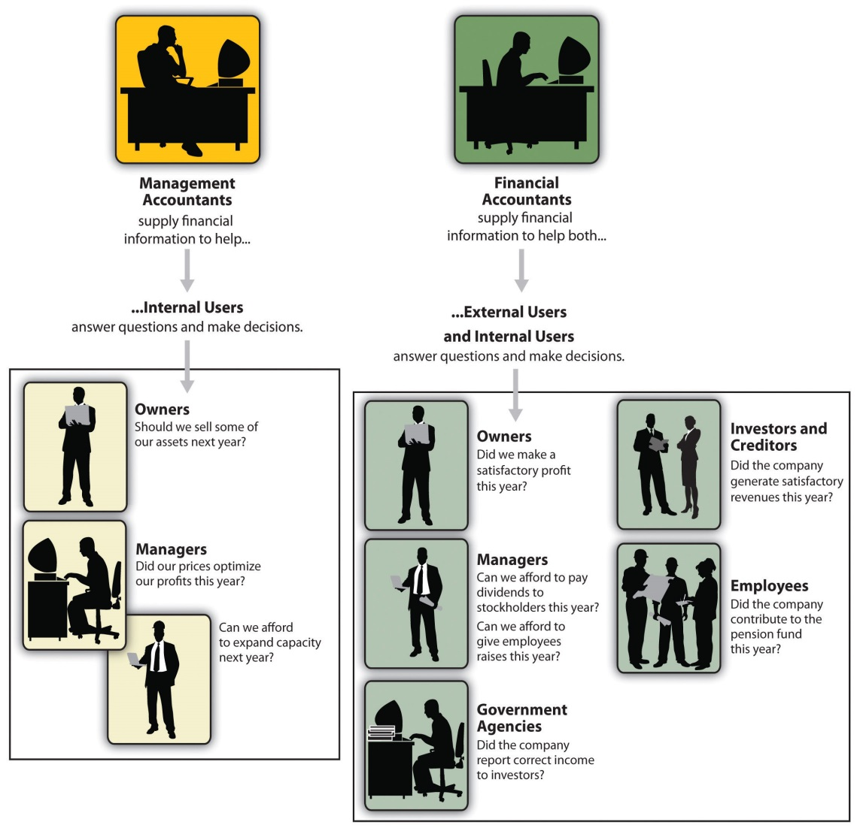

**Question 2**

What is the differences between accounts payable and accounts receivable?

|  |  |  |
| --- | --- | --- |
|  | Account receivable | Account payable |
| Definition | Payment which the company will receive from its customers who have purchased goods and services on credit. Customers who have purchased goods and services are called debtors. | When a company purchases goods on credit which needs to be paid back in a short period of time. Account payable is short-term debt payment which needs to be paid to avoid default. |
| Family | Assets | Liabilities |
| Example | Sold goods RM 800 on credit | Bought goods RM600 on credit |

1. Purchase

|  |  |
| --- | --- |
| Dt | Cr |
| Cash RM 1800 |  |

Cash

|  |  |
| --- | --- |
| Dt | Cr |
|  | Purchase RM 600 |

1. Salaries expenses

|  |  |
| --- | --- |
| Dt | Cr |
| Cash RM 1200 |  |

Cash

|  |  |
| --- | --- |
| Dt | Cr |
|  | Salaries expenses RM 900 |

1. Rental expenses

|  |  |
| --- | --- |
| Dt | Cr |
| Bank RM 800 |  |

Bank

|  |  |
| --- | --- |
| Dt | Cr |
|  | Rental expense RM 2500 |

1. Purchase

|  |  |
| --- | --- |
| Dt | Cr |
| Creditor RM 300 |  |

Creditor

|  |  |
| --- | --- |
| Dt | Cr |
|  | Purchase RM 800 |

1. Cash

|  |  |
| --- | --- |
| Dt | Cr |
| Sales RM 200 |  |

Sales

|  |  |
| --- | --- |
| Dt | Cr |
|  | Cash RM 650 |

1. Cash

|  |  |
| --- | --- |
| Dt | Cr |
| Commission received RM 400 |  |

Commission received

|  |  |
| --- | --- |
| Dt | Cr |
|  | Cash RM 130 |

1. Cash

|  |  |
| --- | --- |
| Dt | Cr |
| Discount received RM 550 |  |

Discount received

|  |  |
| --- | --- |
| Dt | Cr |
|  | Cash RM 340 |

1. Debtor

|  |  |
| --- | --- |
| Dt | Cr |
| Sales RM 800 |  |

Sales

|  |  |
| --- | --- |
| Dt | Cr |
|  | Debtor RM 950 |

**Question 3**

Why does company profit appear as a credit on its balance sheet

## Introduction to Balance Sheet

## Introduction to the Balance Sheet

The balance sheet is one of the four basic financial statements companies prepare each [accounting](https://www.boundless.com/accounting/definition/accounting/) cycle. The balance sheet is a summary of the financial balances of a sole proprietorship, a business [partnership](https://www.boundless.com/accounting/definition/partnership/), a corporation, or other business organization, such as an [LLC](https://www.boundless.com/accounting/definition/llc/) or an [LLP](https://www.boundless.com/accounting/definition/llp/). The balance sheet is also referred to as a statement of financial position because it reflects a company's [solvency](https://www.boundless.com/accounting/definition/solvency/) and financial position. The International Accounting Standards Board, along with country specific organizations and companies set the guidelines for the appearance of the balance sheets.

## What Period Does the Balance Sheet Cover

A balance sheet is like a photograph in that it captures the financial position of a company at a particular point in time. More specifically, it captures the financial position at the end of business on the day the balance sheet is run.

[[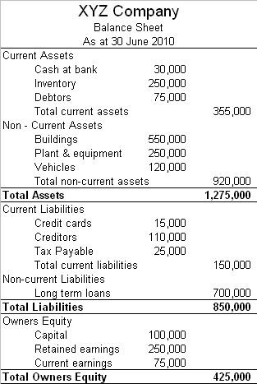](https://www.boundless.com/accounting/textbooks/boundless-accounting-textbook/introduction-to-accounting-1/conveying-accounting-information-20/introduction-to-the-balance-sheet-121-3760/images/the-balance-sheet/)](https://www.boundless.com/accounting/textbooks/boundless-accounting-textbook/introduction-to-accounting-1/conveying-accounting-information-20/introduction-to-the-balance-sheet-121-3760/images/the-balance-sheet/)

## What Items Appear On the Balance Sheet

The balance sheet lists a company's assets, liabilities, and stockholders equity (including dollar amounts) as of a specific moment in time. Assets are the total resources of the business including [cash](https://www.boundless.com/accounting/definition/cash/), notes and [accounts](https://www.boundless.com/accounting/definition/accounts-receivable/)[receivable](https://www.boundless.com/accounting/definition/receivable/), while liabilities are anything the company owes to someone, such as [debt](https://www.boundless.com/accounting/definition/debt/), mortgage or [interest](https://www.boundless.com/accounting/definition/interest/) payments. The stockholder's equity or just equity refers to the ownership interest in a company. The stockholder's equity is determined by subtracting liabilities from assets.

There are two types of balance sheets, classified and unclassified.

Unclassified balance sheets have three major categories: assets, liabilities, and stockholder's equity. The main categories of assets are usually listed first, and typically in order of [liquidity](https://www.boundless.com/accounting/definition/liquidity/) (for example, cash on hand appears above accounts receivable). Liabilities are listed after assets. The difference between assets and liabilities is referred to as equity. According to the accounting equation, equity must equal assets minus liabilities. Equity is either calculated as proprietary or residual. For residual equity [dividends](https://www.boundless.com/accounting/definition/dividend/) to [preferred](https://www.boundless.com/accounting/definition/preferred/) [shareholders](https://www.boundless.com/accounting/definition/shareholder/) are deducted from [net](https://www.boundless.com/accounting/definition/net-income/)[income](https://www.boundless.com/accounting/definition/income/) before calculating residual equity holders' dividend per share.

A [classified balance sheet](https://www.boundless.com/accounting/definition/classified-balance-sheet/) has the same three major categories of assets, liabilities, and stockholder's equity, but it breaks those categories down further to give a better idea of the [profitability](https://www.boundless.com/accounting/definition/profitability/) and strength of the company.

**Question 4**

What is meant by reconciling an account

Account [reconciliation](http://www.investopedia.com/video/play/reconciliation-0/) is also important for businesses. Businesses must reconcile their accounts to check for fraud and to prevent [balance sheet](http://www.investopedia.com/terms/b/balancesheet.asp) errors. Businesses typically use [accounting software](http://www.investopedia.com/terms/a/accounting-software.asp) to help them perform account reconciliations. Mistakes can have serious ramifications for publicly traded companies. For example, an [auditor](http://www.investopedia.com/terms/a/auditor.asp) who reviews the company’s [financial statements](http://www.investopedia.com/terms/f/financial-statements.asp) in accordance with federal regulations such as the Sarbanes-Oxley Act could find a material error, which the company would have to publicly disclose as a failure of controls, a material misstatement and/or a material weakness. Without accurate financial information, a company cannot make well-informed decisions.

## Difference Between Double-Entry Reconciliation and Account Conversion

In double-entry accounting, an accountant posts every financial transaction in two columns of a business's balance sheet. For example, if the business takes out a long-term loan for $10,000, the accountant credits long-term debt or notes payable with that amount and debits the cash column with the same amount. When these amounts are added together, the account reconciles or balances at 0.

Similarly, imagine that a business incurs an invoice for carpet cleaning services. It credits the amount of the invoice in its accounts payable column, and it debits its column devoted to office cleaning and similar expenses for the same amount. When the company pays the bill, it debits accounts payable and credits the office cleaning column.

Under the account conversion method, businesses or individuals compare records such as receipts or canceled checks with the entries in its ledger.

In bookkeeping, a bank reconciliation is a process that explains the difference on a specified date between the bank balance shown in an organization's [bank statement](https://en.wikipedia.org/wiki/Bank_statement), as supplied by the bank, and the corresponding amount shown in the organization's own accounting records.[[1]](https://en.wikipedia.org/wiki/Bank_reconciliation#cite_note-Warren2010-1)

Such differences may occur, for example, because

* [cheques](https://en.wikipedia.org/wiki/Cheque) issued by the organization have not been presented to the bank
* a banking transaction, such as a credit received, or a charge made by the bank, has not yet been recorded in the organization's books
* either the bank or the organization itself has made an error.

Sometimes it may be easy to reconcile the difference by looking at very recent [transactions](https://en.wikipedia.org/wiki/Financial_transaction) in the bank statement and the organization's own accounting records (cash book) and seeing if some combination of them tallies with the difference to be explained. Otherwise it may be necessary to go through and match every transaction in both sets of records since the last reconciliation, and see what transactions remain unmatched. The necessary adjustments should then be made in the cash book, or reported to the bank if necessary, or any timing differences recorded to assist with future reconciliations.

For this reason, and to minimise the amount of work involved, it is good practice to carry out such reconciliations at reasonably frequent intervals. Reconciliations may be assisted by specialised [accounting software](https://en.wikipedia.org/wiki/Accounting_software).

A Bank reconciliation statement is a statement prepared as part of the reconciliation which sets out the entries which have caused the difference between the two balances.

## Bank Reconciliation Defined

Have you ever balanced your checkbook? Why did you do that? Was it to make sure that you didn't make any mistakes when you were adding deposits or subtracting expenses? I bet it was because you wanted to make sure that your balance in your checkbook was the same as the balance in the bank, right? Everything that we just talked about refers to what we in accounting commonly call doing a bank reconciliation. A bank reconciliation is the balancing of a company's cash account balance to its bank account balance.

## Preparing a Reconciliation

Since it is really important to make sure that the cash account and the bank account balances match, a company prepares bank reconciliations on a monthly basis. There are several steps that are involved in this, but, even so, it is a relatively simple thing to do. Let's go through the steps and prepare the reconciliation.

Step 1: Collect the documents that you will need to prepare the reconciliation. The most common documents would be the bank statement that is received from the bank and the check register for the month. In the accounting industry, most check registers are printed off of accounting software and used for the reconciliation. The bank statement tells you what the bank balance was at the beginning of the month, the deposits the bank has on record for the account, the withdrawals that have been made from the account, and the ending balance of the account on a specific date. The check register will show all the deposits and withdrawals that were made by the company during a given time period. There is one key difference between the bank statement and the check register. The bank statement only lists deposits and withdrawals that have processed through the bank, while the check register lists all the deposits and withdrawals that a company had in a specific period, regardless of if it has cleared the bank or not.

Step 2: The second step in preparing the bank reconciliation is the most tedious. The object of this step is to account for all the deposits and withdrawals that a company has recorded and that have also cleared the bank. If you are manually preparing the reconciliation, you would highlight or check off the entries that are common among the two. In a computerized accounting program, you can simply just click on the entries to mark them as cleared. Cleared means that the item has been recorded in both the company's records and the bank's records.

Step 3: Once you have marked the items that are cleared on the check register, you move to the next step. In this step, you will make a list of any items that have been recorded in the check register but have not cleared the bank. Typically, a company will always have outstanding debits in the month. Outstanding debits are checks and other withdrawals that have been recorded in the company's cash account but have not yet been recorded in the bank's accounting records. There may also be outstanding credits that need to be accounted for. Outstanding credits are deposits that have been recorded in company's records but don't yet appear on the bank's records.

Step 4: Now that you have all the outstanding debits and outstanding credits together, it's time to do the math. Any debits that haven't been accounted for will need to be deducted from the balance on the bank statement. Likewise, any credits that have not been accounted for will be added to the balance on the bank statement. In a perfect world, once this step is complete, the current balance in the checkbook should match the adjusted bank statement balance.

Step 5: Notice that I just said, 'in a perfect world the balances would match'. It's not always a perfect world. Sometimes the balances don't match. That's when your detective skills come into play. If the current balance in the checkbook does not match the adjusted bank statement balance, then you have to start looking for errors. The most common error that occurs and is discovered in the reconciliation process is called transposition. Transposition occurs when the order of numbers are inadvertently switched during the recording process. For example, let's say that a check was written for $412 to pay a utility bill but was recorded in the checkbook as $421.00. That error would cause a $9 difference between the two balances. Of course, there could be other errors that cause the balances not to equal. Either a check or a deposit may not have been recorded or something may have been recorded twice. These are things that can be found and fixed in the reconciliation process.

**Conclusion**

Accounting is termed as a process meant for keeping records of the transactions financial in nature. Accounting is a practical, engaging subject with concepts that requires skills in both legal studies as well as mathematics. Accounting enables businesses to analyse the financial performance by determining the profit or loss made during a certain period. Hence it is sometimes called the “language of business”. Accounting involves the process of identifying, measuring, recording and communicating the economic events of an organization (business or non-business) to interested users of the information.

**References**

**1.http://www.businessdictionary.com/definition/accounting-concepts.html**

**2.** [**https://www.accountingcoach.com/blog/profit-credit-on-balance-sheet**](https://www.accountingcoach.com/blog/profit-credit-on-balance-sheet)

**3.** [**http://accounting-simplified.com/financial/what-is-accounting.html**](http://accounting-simplified.com/financial/what-is-accounting.html)

**4.** [**http://www.careerride.com/fa-systems-of-accounting.aspx**](http://www.careerride.com/fa-systems-of-accounting.aspx)

**5.** [**https://www.acowtancy.com/textbook/acca-f3/e4-bank-reconciliations/differences-between-cash-book-and-bank-statement/notes**](https://www.acowtancy.com/textbook/acca-f3/e4-bank-reconciliations/differences-between-cash-book-and-bank-statement/notes)

**Appendix**

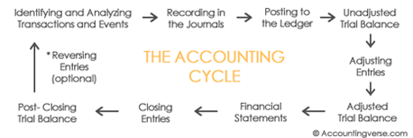

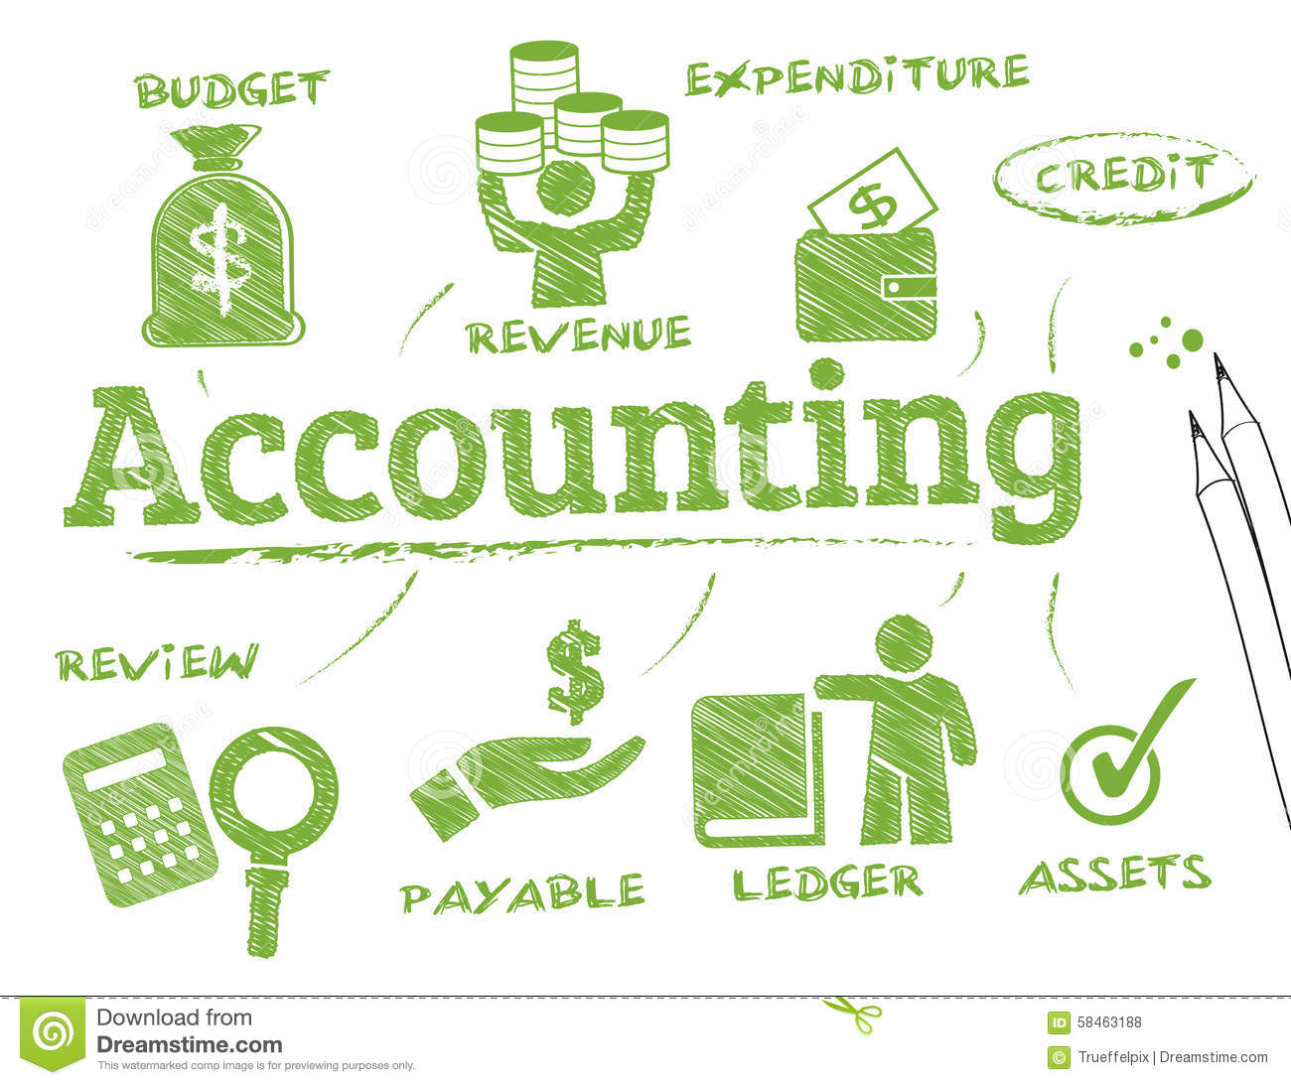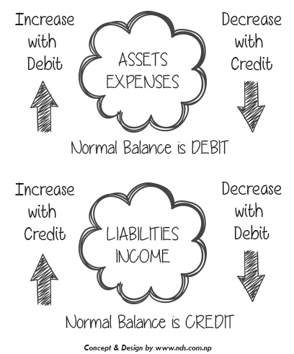

**THE END**